Faculty of Computing
LAB: 3


Name: Gull e Zahra
Sap id: 54154
BSCS-6

LAB - 1
Course | Computer Communications and Network Lab
Course Instructor | Ms. Seemab Karim
Credit Hour | 1
Lab No. | 1
Lab Subject | Computer Network Configuration Commands
Lab Objective | - Introduction to IP addressing  - Identify tools used for discovering a computer’s network configuration with various operating systems.  - Gather information, including the connection, host name, MAC (Layer 2) Address, and TCP/IP Network (layer 3)  - Compare the network information to that of other PCs on the network.  - Learn to use the TCP/IP packet Internet groper (ping) command from a workstation.  - Learn to use the trace route (tracert) command from a workstation.  - Observe name-resolution occurrences using WINS and DNS servers.
Tools | PC/Laptop, Lab Manual

Background
This lab assumes that you are using Windows 11 or Windows 10. This is nondestructive lab that you can perform on any host without changing the system’s configuration.
Ideally, you perform this lab in a LAN environment that connects to the Internet. You can use a single remote connection via a dialup modem or DSL. You will need the IP address information which the instructor should provide.
IP Addressing
IP address stands for “Internet Protocol address.” The Internet Protocol is a set of rules for communication over the internet, such as sending mail, streaming video, or connecting to a website. An IP address, or Internet Protocol address, is a series of numbers that identifies any device on a network. Computers use IP addresses to communicate with each other both over the internet as well as on other networks.
IP addresses are the identifier that allows information to be sent between devices on a network: they contain location information and make devices accessible for communication. The internet needs a way to differentiate between different computers, routers, and websites. IP addresses provide a way of doing so and form an essential part of how the internet works.
An IP address is a string of numbers separated by periods. IP addresses are expressed as a set of four numbers — an example address might be 192.158.1.38. Each number in the set can range from 0 to 255. So, the full IP addressing range goes from 0.0.0.0 to 255.255.255.255.
The internet protocols manage the process of assigning each unique device its own IP address. (Internet protocols do other things as well, such as routing internet traffic.) This way, it’s easy to see which devices on the internet are sending, requesting, and receiving what information.

IP addresses are like telephone numbers, and they serve the same purpose. When you contact someone, your phone number identifies who you are, and it assures the person who answers the phone that you are who you say you are. IP addresses do the exact same thing when you’re online — that’s why every single device that is connected to the internet has an IP address.

There are two types of IP addresses: IPv4 and IPv6. It’s easy to recognize the difference if you count the numbers. IPv4 addresses contain a series of four numbers, ranging from 0 (except the first one) to 255, each separated from the next by a period — such as 5.62.42.77.

IPv6 addresses are represented as eight groups of four hexadecimal digits, with the groups separated by colons. A typical IPv6 address might look like this: 2620:0aba2:0d01:2042:0100:8c4d:d370:72b4.

Network Configuration
Part A Using ipconfig command
Step 1: Connect to the Internet
Establish and verify connectivity to the Internet. This step ensures the computer has an IP address.
ipconfig command is used to see the network (IP) information of your computer.

In simple words ipconfig tells you how your computer is connected to the network.

Why do we use ipconfig?
- To check internet/network problems
- To know your IP address
- To see if you are properly connected to the router
- Used by students, network admins, and IT support

What information does it show?
- IP address (your computer’s network number)
- Subnet mask (network size)
- Default gateway (router address)
- Whether you are using IPv4 or IPv6
Step 2: Gather TCP/IP configuration information
- Windows NT/2000/XP: Use the start menu to open the command prompt (Start/Programs/Accessories/Command Prompt or Start/Programs/Command Prompt OR click on start and then press cmd)
Windows 10: Press Window+R to open Run box. Then type cmd and then click on ok to run a regular command prompt.
- Type ipconfig and press Enter key.
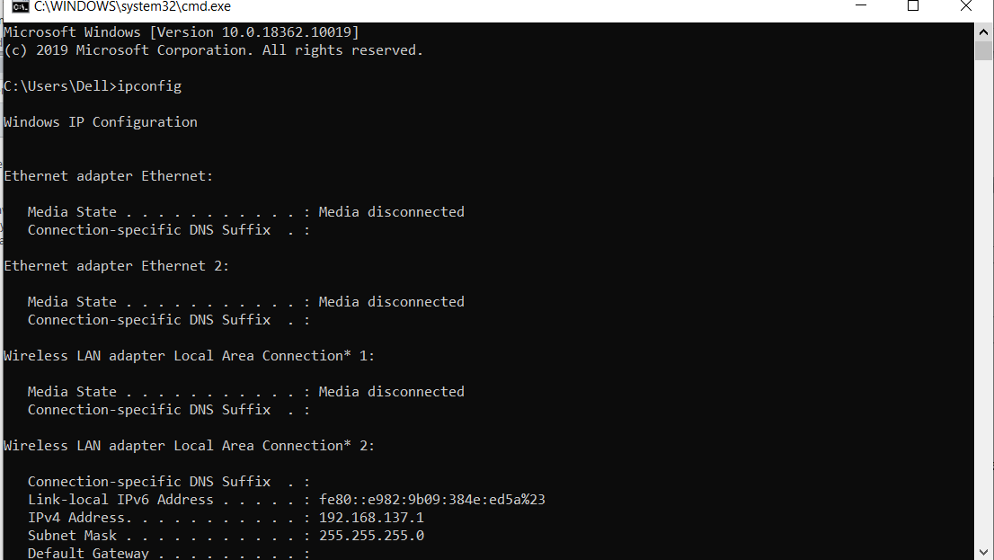
- The screen shows the ip address, subnet mask and the default gateway. The ip address and the default gateway should be in the same network or subnet. Otherwise the host wouldn’t be able to communicate outside the network OR Otherwise, your computer cannot talk to the router.
How do we check if they are in the same subnet?
Compare the network part of both IPs.

Example 1 (Same network ✅)
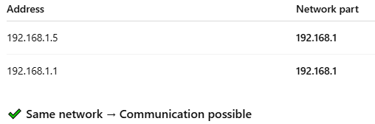
Example 2 (Different network ❌)

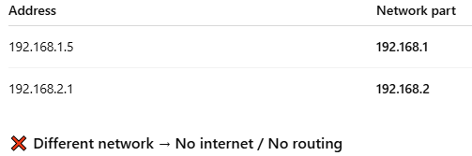

Step 3: Record the following TCP/IP information for this computer
- IP address: 172.21.25.50
- Subnet mask: 255.255.255.0
- Default Gateway: 172.21.25.1
Step 4: Compare this computer’s TCP/IP configuration to that of others on the LAN
If this computer is on LAN, compare the information of several machines (Hosts).
- Are there any similarities: Yes Subnet mask and default gateway are same.
- What is similar about the IP address? First group of 3 bits are same.
- What is similar about the default gateway? All same
- Is there anything similar in subnet mask? All same
- Record a couple of the IP addresses (of your nearby hosts)
- 172.21.25.51
- 172.21.25.49
- 172.21.25.15
Step 5: Check Additional TCP/IP configuration information(use ipconfig/all)
To check the additional TCP/IP configuration information use ipconfig/all command,It shows full TCP/IP configuration of all network adapters (active and inactive).
It tells who you are on the network and how you’re connected.
What ipconfig /all shows
- IP Address
- Subnet Mask
- Default Gateway
- DNS Servers
- MAC Address (Physical Address)
- DHCP Enabled / DHCP Server
- Shows whether IP is assigned automatically
- Tells which server gave your IP
- Network Adapter Details
- Wi-Fi / Ethernet info
- Connection status (connected or disconnected)
- To see more information, type ipconfig/all and press Enter key. The next figure shows the detailed IP configuration of this computer on the screen.
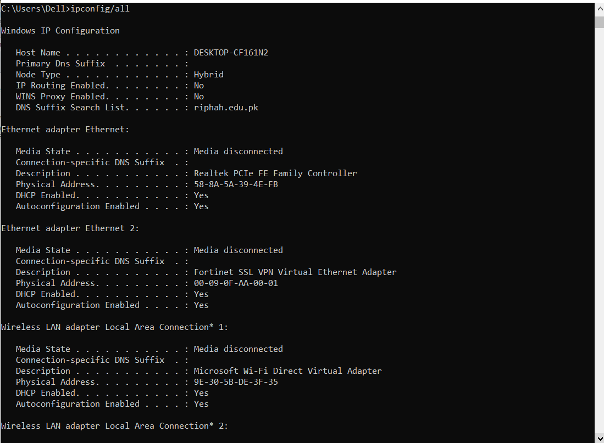
- You should see the following information:
  - The host name
  - The physical address of this machine
  - IP address
  - Subnet mask
  - Default gateway
- In the LAN, compare your results with a few nearby computers. What similarities do you see in the physical (MAC) address?
All MAC addresses start with 7C-D3-0A which means the manufacturer is same.
- Write down the computer’s host name: LAB202-PcUser11
- Write down the host name of couple of other computers.
  - LAB202-PcUser10
  - LAB202-PcUser12
  - LAB202-PcUser9
  - LAB202-PcUser07
  - Step 6: Close the screen when finished.
Part B Using PING TRACERT from a workstation
PING TRACERT is a network diagnostic tools that is commonly used from a workstation to troubleshoot network connectivity issues.
Purpose: To check if another device (computer, server, and router) is reachable on the network.
Step 1:
- Open the command prompt.
- Type ping, give space and type the IP address of a computer recorded in the previous lab.
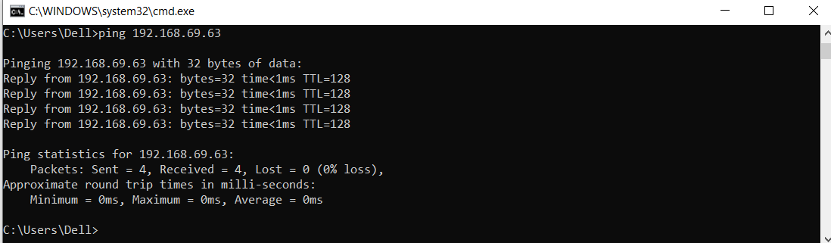
Command: ping 192.168.69.63
It is a command used to check whether the device with IP address 192.168.69.63 is reachable from your computer.

Break it into parts
- ping
→ A network testing command
→ Sends small test messages (ICMP Echo Requests)
- 192.168.69.63
→ The IP address of the target device
→ Usually a device on the same local network (LAN)

What actually happens?
- Your computer sends a small message to 192.168.69.63
- If the device is ON and connected:
  - It sends a reply back
- Your computer measures:
  - Is the device reachable?
  - How long the reply takes (time)?
What the output shows?
Ping request and replies
Reply from 192.168.69.63: bytes=32 time<1ms TTL=128
This line appears 4 times, meaning 4 packets were sent and all were received.
This confirms successful communication.
Ping statistics
Packets: Sent = 4, Received = 4, Lost = 0 (0% loss)
Explanation:
- Sent = 4 → 4 packets sent
- Received = 4 → All packets came back
- Lost = 0 → No packet loss
Its mean Network connection is stable and healthy.
Round-trip time
Minimum = 0ms, Maximum = 0ms, Average = 0ms
Explanation:
- Data traveled very quickly
- Typical result when pinging a device on the same local network (LAN)
Ping uses the Internet Control Message Protocol (ICMP) echo-request and echo-reply feature to test physical connectivity. Because ping report on four attempts, it gives an indication of the reliability of the connection. Look over the result and verify that the ping was successful. Was the ping successful? If not, report to the instructor.

If ping is not successful the information will display like this
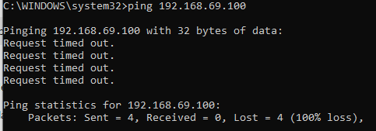

What this means

Request timed out
- Your computer sent the ping request
- No reply came back
- The destination device did not respond

Ping statistics
- Sent = 4 → 4 packets were sent
- Received = 0 → No replies
- Lost = 4 (100% loss) → Complete failure

Why ping can fail (common reasons)
- ❌ The target device is OFF
- ❌ Wrong IP address
- ❌ Device is not connected to the network
- ❌ Network cable / Wi-Fi issue
- ❌ Different network (routing problem)

- Ask the IP address of the nearby computers and ping. Note the result.
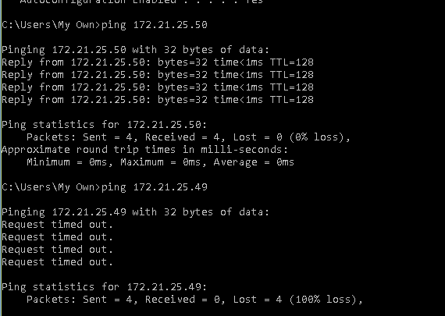
- Ping the Loop back ip address. Type the following address.
Ping 127.0.0.1
If loop back testing is successful then the TCP/IP is properly installed and functioning on this computer.
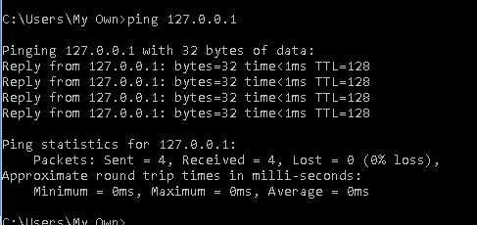
Is it successful? Yes
- Ping the host name of the computer that you recorded in previous part.
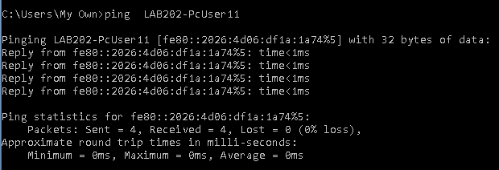
- Ping the Microsoft website www.microsoft.com
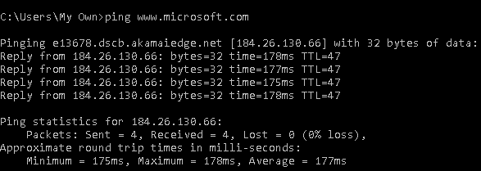
- Ping the Microsoft website google.com
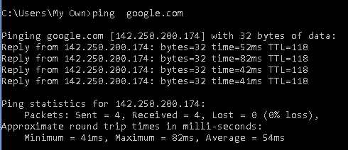
Step 3: Trace the route to Riphah International University’s Website
Type tracertwww.riphah.edu.pk and press Enter key
The result shows the complete route to the website and the number of hops in the path.
Trace a local host name or IP address in your local area network (LAN).
Record the output and interpret.
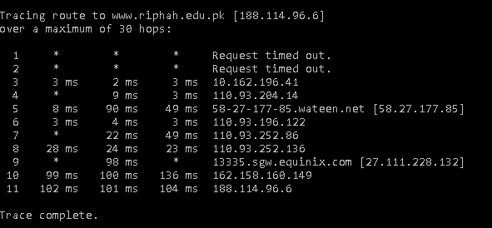

Traceroute successfully reached the destination (188.114.96.6). Initial hops timed out due to routers blocking ICMP responses, which is normal. Overall network path is functioning correctly.
Step 4: Last Practice
is a network diagnostic command that combines the features of PING and TRACERT.
It shows:
- The path (routers/hops) to the destination
- Packet loss at each hop
- Network reliability over time
Practice on (pathping google.com) and Record the output and interpret.
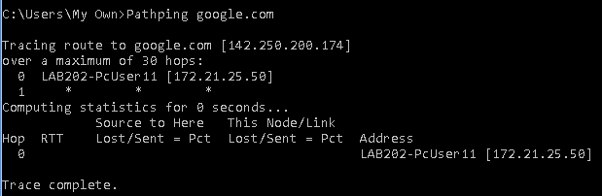
PathPing to google.com did not complete successfully. Only the local node (172.21.25.50) is shown, and subsequent hops did not respond. This typically occurs due to network restrictions, firewall settings, or ICMP blocking.
What is TTL?
TTL stands for Time To Live.In networking, TTL is a value that limits how long a data packet can travel in a network before it is discarded.

How TTL works
- When a packet is sent, it is given a TTL value
- Each router (hop) the packet passes through reduces TTL by 1
- When TTL becomes 0, the packet is discarded
- A message is sent back saying “Time exceeded”

